Tech Journal Lab 01 Tiseo

1. I “cabled” and set the LAN and WAN. This was done by setting them up via vSphere outside of the fw01 system.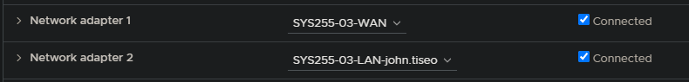 They were then assigned manually inside the fw01 console. When setting them up, remember to not use DHCP. The reasons why haven’t been explained to me, but just don’t do it. This will be updated when I figure out exactly why. As well, when asked to use https, I instead decided to opt for a more secure tunnel.
2. I configured the network on the workstation to be my LAN rather than the default. I simply had to browse my available networks to find it.
3. I had to create a new admin user for myself. I went into lusrmgr.msc, created a new user, and then modified the properties to allow admin access.
4. After that, I went into the network properties via control panel, and modified the TCP/ICP settings. Don’t even try going through settings as that just leads to a whole bunch of nothing. NOTE: it didn’t work until I hit validate afterwards, before I couldn’t connect to the gate at all.
5. I modified the firewall via pfsense to allow entry from my Private Network via WAN. Luckily, I could leave stuff blank, because I had no idea what half of the options on the step pages would do.

This lab was easy for the most part, but it was a little tedious around halfway through.